2. What is the correlation between GDP and women’s labor participation?

Similar U-Shaped GDP development. Compared to women 's unemployment rate.

Extend the findings to worldwide range to see whether it still stands.

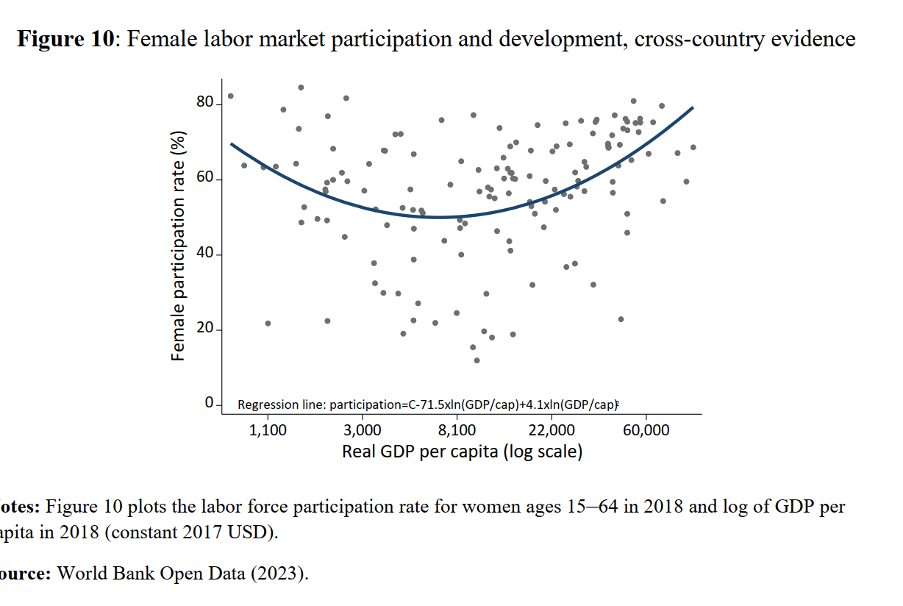

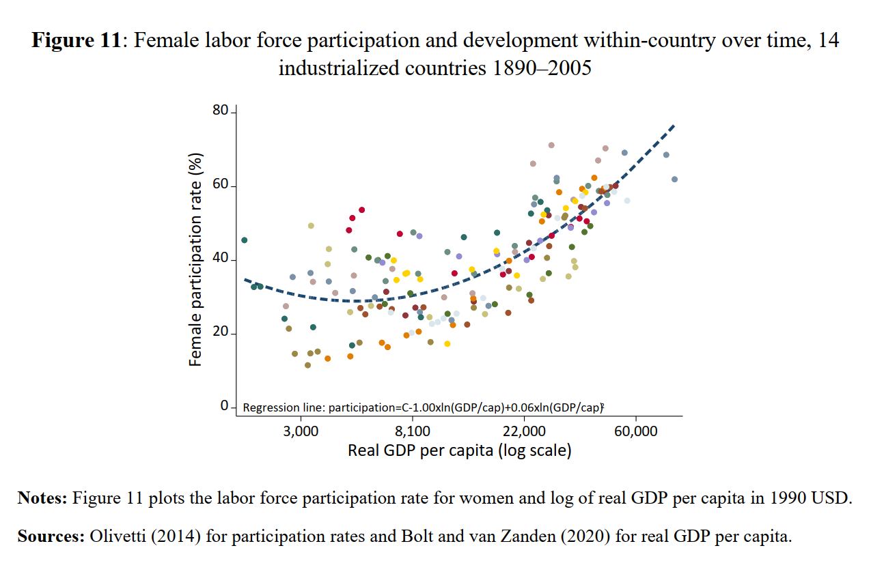

* We might see a U-shaped association. Due to their need for additional income, women may have higher labor force participation rates in less developed economies. Women's involvement rates may decline as economies develop because of increased access to education and other opportunities. Women's labor force involvement may, however, increase once more as economies achieve higher levels of development, frequently in occupations requiring greater ability and professionalism.